What are we going to do about livestreaming?

Windows streaming media server for putting(IIS media services)

<https://elinetechnology.com/how-to-put-live-video-on-your-website-from-a-surveillance-camera/>

<https://randomnerdtutorials.com/video-streaming-with-raspberry-pi-camera/>

This is a great option to go with if we want to base the server for the live stream off the pi.

It also created its own website too and that leads to is possible to change it to go to a website outside of the raspberry pi.

Though it is a great option to help with building something to be able to use to be able to livestream from the raspberry pi to run what we need to run but we would have to try to find out how to record the video only at a certain time and how to add in alerts.

<https://www.youtube.com/watch?v=i9mJzdLYsVo>

[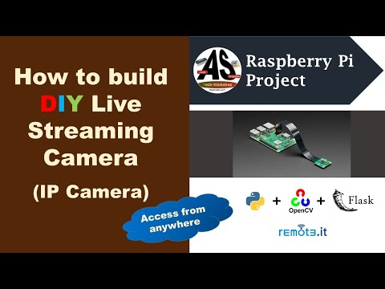](https://www.youtube.com/watch?v=i9mJzdLYsVo)

Option 1:

Make the raspberry pi they producer of the stream

Option 2:

Streaming/recording w/ motion sensor ideas

<https://raspberrypi-guide.github.io/electronics/image-and-video-recording> *

<https://raspberrypi.stackexchange.com/questions/46987/motion-detection-and-recording-video-with-webcam>

<https://thepihut.com/blogs/raspberry-pi-tutorials/motion-triggered-video-recording>

<https://forums.raspberrypi.com/viewtopic.php?t=297259>